EXPT NO:7 | IMPLEMENT ADVANCED CHART TYPES USING TABLEAU AND  POWER BI
DATE: 14.08.2026

PRE-LAB QUESTIONS

- What is data integration in the context of Business Intelligence (BI)?
Data integration is the process of collecting and combining data from different sources into a single, unified system. In Business Intelligence, data may come from CSV files, Excel sheets, databases, websites, or other applications. The integrated data can be cleaned, transformed, and analyzed together. It helps organizations get a complete view of their business information. Data integration also improves reporting and supports better decision-making.

- Explain the difference between a join and a data blend in Tableau.
A join combines two or more tables using a common field such as Region or Customer ID. The tables are combined at the data-source level before creating visualizations. A data blend combines data from different data sources at the visualization level. In blending, the original data sources remain separate. Joins are useful when the data has a common structure, while blending is useful when data comes from different sources.

- What are relationships and cardinality (e.g., one-to-many, many-to-many) in Power BI's data model?
A relationship in Power BI is a connection between two tables using a common column or field. For example, the Region column can connect a Sales table with a Regional Target table. Cardinality describes how records in one table are related to records in another table. The common types are one-to-one, one-to-many, and many-to-many. Correct relationships and cardinality help Power BI calculate and display data accurately.

- Why is data quality (e.g., consistent naming conventions, data types) crucial when integrating data from different sources?
Data quality is important because incorrect or inconsistent data can produce inaccurate analysis and reports. When combining different sources, column names, values, and data types should be consistent. For example, "N. America" and "North America" should be standardized to the same value. Missing values and duplicate records should also be handled properly. Good data quality ensures accurate calculations, visualizations, and business decisions.

- Name two common challenges encountered during data integration.
Two common challenges in data integration are mismatched data values and different data types. The same information may be represented differently in different datasets, such as "N. America" and "North America". Missing values and duplicate records can also affect the integration process. Another challenge is differences in the level of detail or granularity between datasets. These issues need to be identified and corrected before analysis.

IN-LAB EXERCISE:
OBJECTIVE:
To connect, combine, and model data from multiple sources in Tableau and Power BI and create a unified, comprehensive dashboard for holistic analysis.

PROCEDURE:
- Data Collection:
  - Import two datasets:
    - Dataset 1: Sales Data (CSV) → Order ID, Order Date, Region, Sales Amount
    - Dataset 2: Regional Sales Targets (Excel) → Region, Sales Target, Target Year
- Data Preparation and Transformation:
  - Clean datasets (e.g., standardize "N. America" → "North America"). • Ensure correct data types (numeric for Sales, date for Order Date).
  - Handle missing values appropriately.
- Data Integration and Modeling:
  - Tableau: Create a join/relationship on the Region field in the Data Source pane.
  - Power BI: Use the Model view to create a relationship on Region; define cardinality (e.g., many-to-one).
- Create Calculated Fields for Comparison:
  - Target Achievement % = (SUM(Sales) / SUM(Sales Target)) * 100
  - Sales vs. Target Variance = SUM(Sales) - SUM(Sales Target)
- Design a Comprehensive Dashboard:
  - Combine visuals from both sources.
  - Add KPI cards: Total Sales, Overall Target Achievement %.
  - Use gauge/bullet charts for region-wise target performance.
  - Combined bar chart: Actual Sales vs. Target by Region.
  - Map visualization: Sales vs. Target Variance by region.
- Validate Data Integrity:
  - Cross-check joined data for accuracy.
  - Ensure dashboard filters correctly update visuals.
- Publishing and Sharing:

  - Tableau: Publish to Tableau Public or Server.
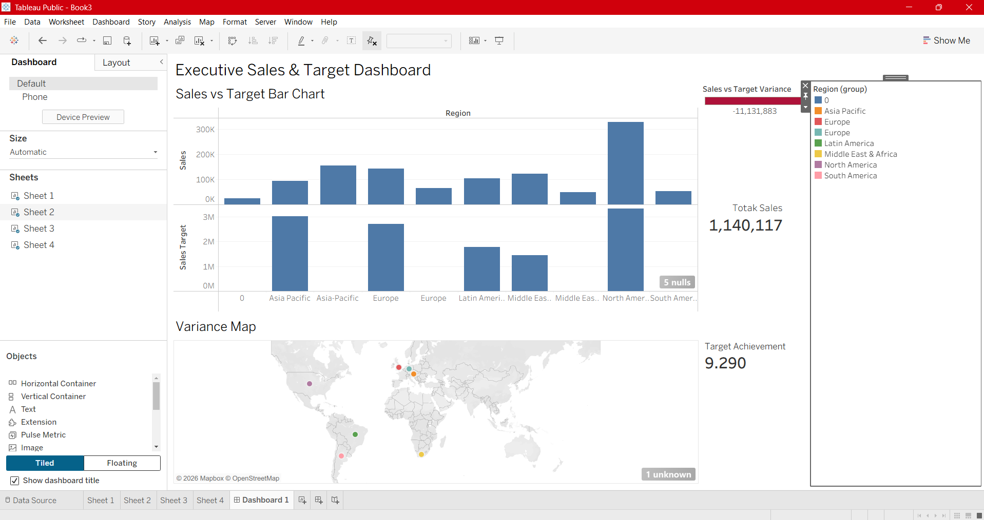

  - Power BI: Publish to Power BI Service and share.
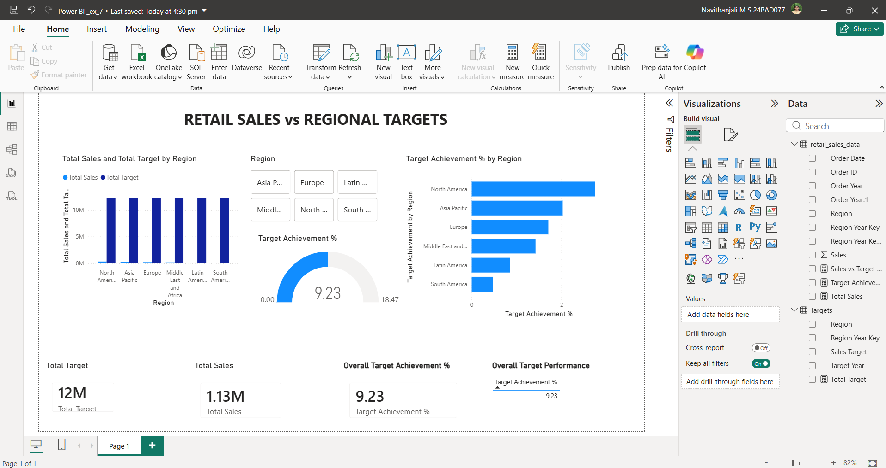
Experiment Datasets:
  - Dataset 1: Retail Sales Data (CSV) → Order ID, Order Date, Region, Sales
  - Dataset 2: Regional Sales Targets (Excel) → Region, Sales Target, Target Year

POST-LAB QUESTIONS :
- How did integrating the sales targets data provide a more complete analytical picture than using the sales data alone?
The sales dataset only shows the actual sales made by different regions. By integrating the regional sales target dataset, we can compare actual sales with the expected sales target. This allows us to calculate Target Achievement % and Sales vs. Target Variance. We can identify regions that exceeded their targets and regions that performed below expectations. Therefore, integrating target data provides a more complete view of business performance.
- Describe the type of join or relationship you used to combine the two datasets and explain why it was the appropriate choice.
A many-to-one relationship was used between the Sales Data and Regional Sales Targets using the Region field. The Sales table contains many records for each region because there can be many orders from the same region. The Regional Targets table contains one target value for each region. Therefore, many sales records are related to one regional target. This relationship is appropriate because it avoids unnecessary duplication of target information.
- What challenges, if any, did you face regarding data granularity or mismatched keys (e.g., different region names) between the two sources?
One of the main challenges was ensuring that the Region values were the same in both datasets. For example, one dataset might contain "N. America", while the other contains "North America". These values need to be standardized before creating the relationship. Another issue can occur when the sales data contains many records for a region while the target data contains only one record. Proper relationships must be created to avoid incorrect calculations or duplicated target values.
- How can creating variance calculations (e.g., Sales vs. Target) help a business manager make better decisions?
Variance calculation shows the difference between actual sales and the target sales. A positive variance means that the actual sales are higher than the target, while a negative variance indicates that the target was not achieved. Managers can use this information to identify high-performing and low-performing regions. They can take corrective actions such as improving marketing, changing sales strategies, or providing additional resources. Thus, variance analysis supports better planning and decision-making.

- What other data source (e.g., marketing campaign data, customer demographics) could you integrate to further enrich this analysis, and what new insights might it provide?
Marketing campaign data can be integrated with the existing sales and target datasets. It could contain information such as campaign type, advertising cost, region, and campaign duration. By combining this data with sales information, we can determine whether a particular marketing campaign increased sales. We can also identify which regions and campaigns generated the best results. This can help managers plan more effective marketing strategies and allocate their budget efficiently.

RESULT:

The retail sales and regional targets datasets were successfully connected, cleaned, and integrated in Tableau and Power BI. Relationships between the sources created a unified data model. The dashboard visualized sales performance against targets, enabling variance analysis and providing insights into regional performance not possible with a single data source.

ASSESSMENT

Description |  | Max Marks | Marks Awarded
Pre Lab Exercise |  | 5
In Lab Exercise |  | 10
Post Lab Exercise |  | 5
Viva |  | 10
 | Total | 30
 | Faculty Signature

